FRONTEND DEVELOPMENT

HANDS – ON 1: HTML5 Semantic Structure & CSS3 Foundations

TASK 1: Build the Page Skeleton with Semantic HTML5

HTML5

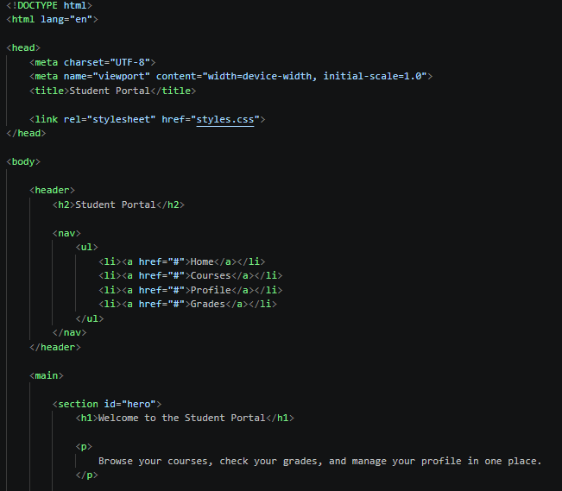
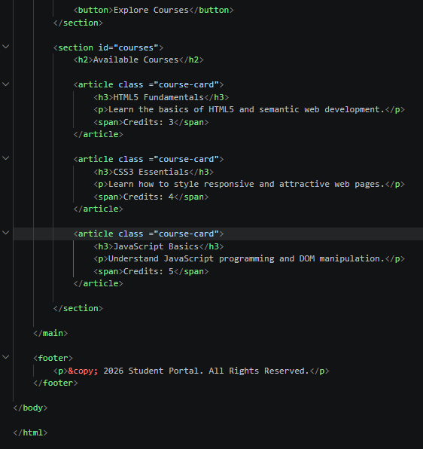

CSS3
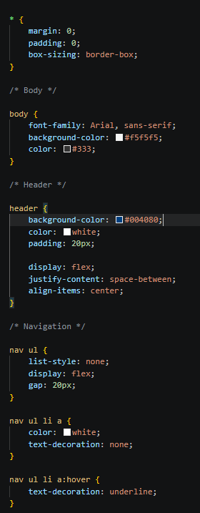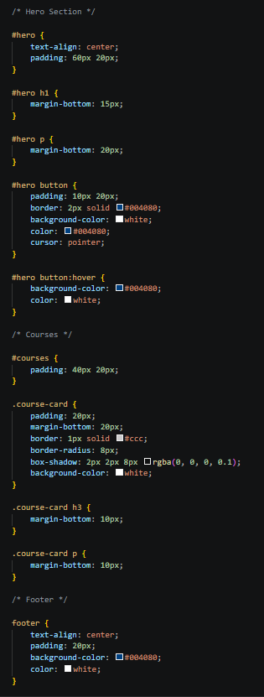

OUTPUT:

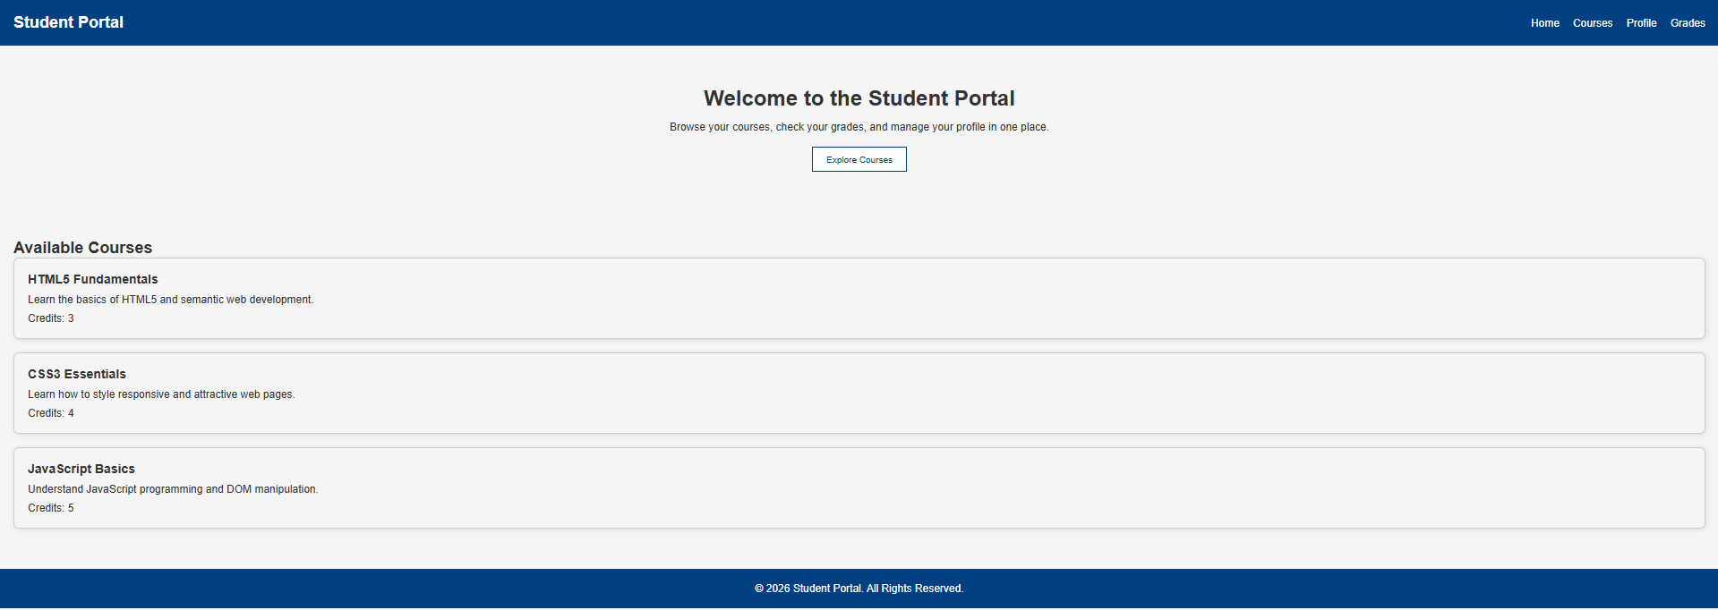

HANDS-ON 2 : CSS Flexbox, Grid & Responsive Design
Output:
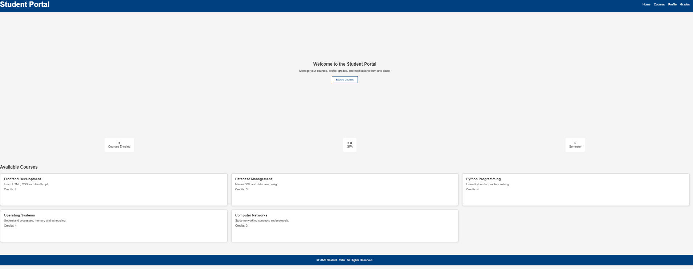

HANDS-ON 3 : JavaScript ES6+ & DOM Manipulation
